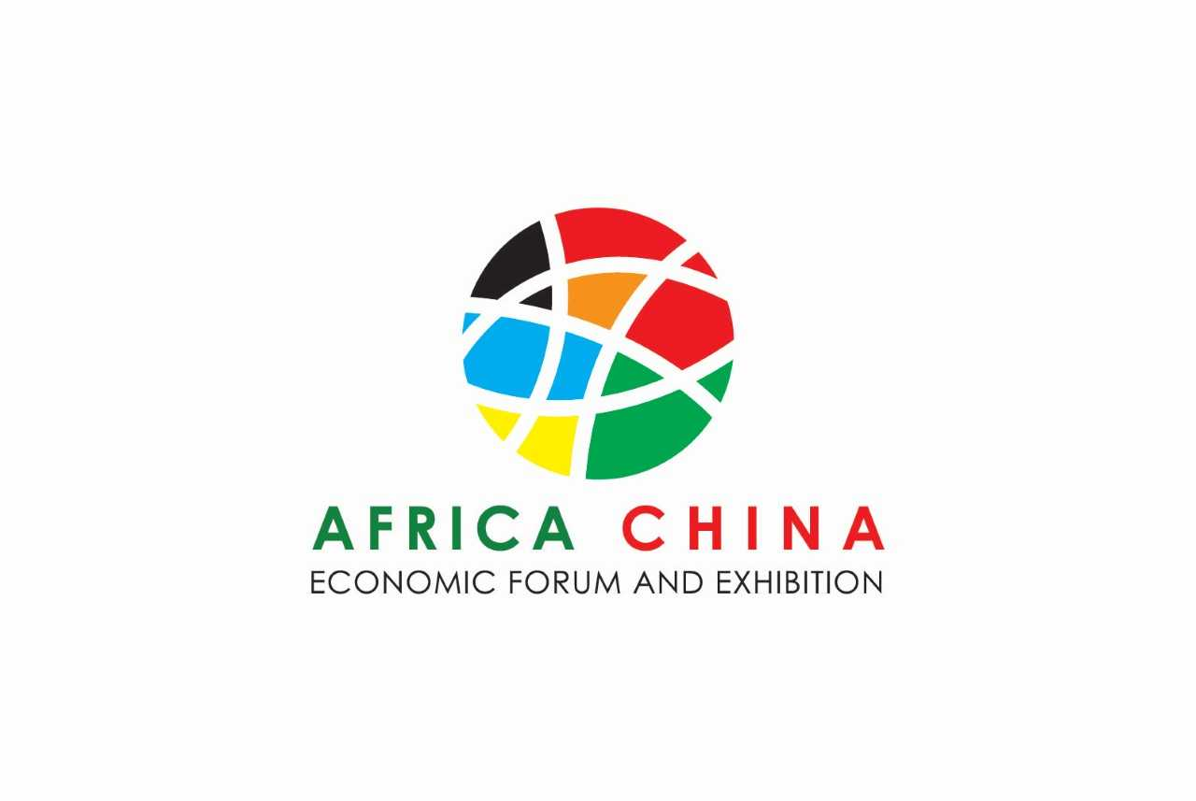

“Africa-China Sustainable Cooperation on Economic Structural Transformation, Towards 2030 Agenda”

3rd – 7th July 2018

Djibouti

Background

The 2030 Agenda for Sustainable Development calls for special attention to sustainable infrastructure development. Sustainable Development Goal9 “Build resilient infrastructure, promote inclusive and sustainable industrialization and foster innovation” is an explicit target which is also considered as means and enabler for the achievement of the 17 Sustainable Development Goals (SDGs). Population growth, migration and urbanization trends in emerging economies and developing countries in Africa increased the demand for infrastructure for sustainable development and 2030Agenda. Good infrastructure is needed to provide resilience, combat poverty as well as for public service delivery, such as education, healthcare or access to water and energy, achieve food security and improved nutrition and promote sustainable agriculture.
Djibouti, has an important strategic location in Horn of Africa near the world's busiest shipping lanes and close to Arabian oilfields. The country is a key point in Maritime Silk Road under the Belt and Road Initiative (BRI). It is also the first connection point between Asia, Africa and the European market, and the gateway for trade and exchange for East Africa. In the Djibouti Vision 2035’, the Government identifies multiple development priorities aimed at graduating to middle-income country status and becoming a major commercial, logistic and trade service regional hub and a destination for foreign investment. Djibouti, has experienced exceptional economic growth in recent years by leveraging the country strategic location near the world's busiest shipping lanes and close to Arabian oilfields. The member of the League of Arab States (Arab League) and the Common Market for Eastern and Southern Africa (COMESA) is among the top 10 performers in the GDP growth, GDP growth in 2017 is estimated at 7.1 percent, mainly derived by investment in the infrastructure for Ports and Free Zones. The growth and the infrastructure boom makes Djibouti, the ideal place for hosting the first Africa-China Economic forum and Exhibition.
In recent years, the trade and investment cooperation between China and Africa has increased steadily. China, is now the largest trade partner for Africa. in the same time, most of the African countries are experiencing reform for industrialization. Building on global initiatives such as Belt and Road Initiative, the 2030Agenda call for sustainable infrastructure and China’s industrial production capabilities, China-Africa Economic cooperation can create a golden opportunity for economic growth in Africa. The cooperation can contribute to growth, promote manufacturing, enhance the ability for self-development, and create more job opportunities. This will ultimately support the economic structural transformation and achievement of the SDGs in Africa and hence significantly roll back poverty.
Realizing the 2030Agenda means of SDGs implementation refers among others to multi-stakeholder partnerships. Public-private partnerships (PPPs) will become increasingly important as a way of delivering sustainable infrastructure that can accelerate economic opportunities and SDGs; The Government of the Republic of Djibouti, Ports and Free Zones Authority (DPFZA) in Djibouti, China Council for the Promotion of International Trade (CCPIT) and Trade Development Bureau, Ministry of Commerce (MOFCOM) , the Government of China, Trade Development Bureau China and Made in Africa Initiative, China Merchant Group in partnership in partnership with the United Nations Development Programme (UNDP) are organizing the first International Africa-China Economic Forum and Exhibition from 3rd to 7th July 2018 in Djibouti, under the theme “Africa-China Sustainable Cooperation on Economic Structural Transformation, Towards 2030 Agenda”
The forum will be a platform for discussion between China and Africa on economic cooperation and utilization of trade opportunities between the two economic blocks as breakthrough point to promote industrialization and investment for sustainable development. The forum plans to make itself an annual event hosted in Djibouti. Each year the conference will focus on specific topic related to 2030 Agenda and the economic cooperation between African countries and China. The event will consist with Davos style panel discussion and deliberation of scientific papers, exhibition, business match making meeting and field visits. The “one alliance + 4 platforms” modality could be formed, Africa-China Sustainable Investment and Trade Alliance and trade cooperation platform, financing cooperation platform, interconnection and intercommunication platform (logistical exchange platform) and industrial development cooperation platform. The forum will conclude by a press-release and statement from the partners to the forum highlighting key recommendation and follow up action
The Economic forum and Exhibition participation includes government officials China and Africa, Representatives from International Organizations, International Development think tanks concerned with 2030 Agenda and private sector, associations, private sectors, financial institutes.
For this year the forum will witness the event f th official inauguration of the free zone facility developed by IDIPO.
Objective
The main objective of the conference is to “Promote the opportunities for economic collaboration and private sector transformation cooperation between Africa and China for enhancing sustainable development”.
This year the forum will focus on the recently developed infrastructure in Djibouti, the outcome of the public private partnership between China and Djibouti and how can the African continent benefit from the spillover of the improved logistics network passing through Djibouti to boost economic competitiveness and productivity, value addition of local manufacturing, industrialization and job creation.
Partners to the Economic Forum:
- The Government of the Republic of Djibouti
- Ports and Free Zones Authority (DPFZA) in Djibouti
- Department of Trade and Investment Promotion, China Council for the Promotion of International Trade (CCPIT)
- Trade Development Bureau, Ministry of Commerce of the People’s Republic of China (MOFCOM)
- China Merchant Group (CMG)
- Made in Africa Initiative (MIAI)
- United Nations Development Programme (UNDP)

Agenda: Africa- China Economic Forum and Exhibition
The Government of the Republic of Djibouti, Ports and Free Zones Authority (DPFZA) in Djibouti, Department of Trade and Investment Promotion, China Council for the Promotion of International Trade (CCPIT),Trade Development Bureau, Ministry of Commerce of the People’s Republic of China (MOFCOM), and Made in Africa Initiative in partnership with the United Nations Development Programme (UNDP) are organizing the first International Africa-China Economic Forum and Exhibition under the theme “Djibouti, a Gateway for Sustainable Development in Africa” 3rd -6th July 2018 in Djibouti. The forum will be a platform for discussion between China and Africa on economic cooperation and utilization of trade opportunities between the two economic blocks as breakthrough point to promote industrialization and investment for sustainable development.
The Economic Forum will be accompanied by two events Opening of the IDIPO free zone and China-Africa Exhibition
\
3rd July Guests Arrival and Registration

4th July 2018
Venue: Kempinski Hotel
Opening of the Exhibition

Exhibition and Business Match making exchanges Field visit in Djibouti Industrial Park 4^{th-} 7th July 2018

4th July 2018
Venue: Kempinski Hotel 19:30 – 21:00
Welcome Reception
5th July 2018
09:00- 10:30
Venue: IDIPO Free Zone
Opening of The Free-Zone
H.E. President Ismaïl Omar Guelleh, The Republic of Djibouti
08.00-08.55 | Welcome of dignitaries and guests
08.00-09.00 | Call for order by MC
09.00-0.05 | Blessing
09.05-09.08 | Water Blending Ceremony, Mr. Bai Jingtao, Mr. Xu Jian, and Mr. Aboubaker
09.10- 9.18 | Enterprises license granting, Dr. Hu Jianhua and Mr. Aboubaker
09.18-09.28 | Speech by the Chairman of Djibouti Port & Free Zone Authority, Mr. Aboubaker Omar Hadi
09.28-09.33 | Speech by the General Manager of China Merchants Group, Mr. Fu Gangfeng
09.33-09.38 | Speech by Ambassador to Djibouti of PRC, Mr. Fu Huaqiang
09.38-09.50 | Opening Remarks by the President of Republic to Djibouti, H.E. Mr. Ismail Omar Guelleh
09.50-09.55 | Ribbon cutting & container truck entering the main gate
09.55-10.05 | Group photo shooting
10.05- 10.30 | Inauguration of DIFTZ plate at the entrance of office tower and the visit of the 16th floor H.E. Mr. Ismail Omar Guelleh and designated VIPs
10.05-10.30 | End of ceremony and the guests move for the forum
5th July 2018- 11:00- 12:40
Venue: People’s Palace
Opening of the Economic Forum
H.E. President Ismaïl Omar Guelleh, The Republic of Djibouti
10.30 – 10.55 | Participants arrival & registration
10.55 – 11.00 | Call to Order by MC
11.00 – 11.10 | Djibouti Ports and Free Zones Authority, Chairman, Mr Aboubaker Omar Hadi
 | Video (3 mins)
11.10 – 12.00 | Welcome Remarks | China Merchant Representative Group, Mr. Gangfeng Fu, General Manager
 | Key Remarks | United Nations Under Secretary General and UNDP Associate Administrator, Mr. Tegegnework Gettu
 | Official Remarks | Department of Trade and Investment Promotion, China Council for the Promotion of International Trade (CCPIT), Mr. Wei Zhang, Vice Chairman
 | Official Remarks | Trade Development Bureau, Ministry of Commerce of the People’s Republic of China, Mr. Guoyong Jia, Vice Director
 | Welcome Remarks | Ambassador to Djibouti of P.R. China, Mr. Fu Huaqiang
 | Official Remarks | African Union Representative
12.00 – 12.05 | Short Video
12.05 – 12.20 | Official Opening of the Conference  H.E. President Ismaïl Omar Guelleh, The Republic of Djibouti
12.30 – 12.40 | Call to Order by MC for Group Photo
12.40 – 14.00 | Lunch

Session 1: Africa-China sustainable trade and investment cooperation to achieve Sustainable Development Goals (SDGs)
This session will explore the economic and social impact and lessons from Africa-China collaboration on industrialization, trade and investment to date.

14:00-15:30 | Presentation: Mr. Qiyuan Lu, president of Eastern Industrial Zone Ethiopia, “Eastern Industry Zone- Experience and Implication of the “Belt & Road Initiative” and China-Africa sustainable cooperation”  Moderator: United Nations Economic Commission for Africa, Mrs Vera Songwe/Representative  Panel:  - Mr. Aboubaker Omar Hadi, Chairman, Djibouti Ports and Free Zones Authority,  - Dr. Cheng Cheng, Chongyang Financial Institute, Renmin University of China & Made in Africa Initiative  - Mr. Moritz Weigel, China Africa Advisory  - Mr. Tewodros Ashenafi, Chairman of SouthWest Energy  - Mr. Qiyuan Lu, President of Ethiopia Eastern Industry Zone  - Mr Adam Iskouned , CEVITAL  - Mr. Ahmed Osman Ali, Governor of the Central Bank of Djibouti
Session 2: Economic Transformation and financing Development in Africa
This session will discuss financing the SDGs and the opportunities created by Economic transformation

15.30 – 17:00 | Presentation: Mr. Renhong Ma, Chairman of Guangdong Logistics Profession Association, “The experience of economic transformation in Guangdong and how Africa countries can capture this golden opportunity”.  Moderator: Mrs. Tumi Makgabo,  Panel:  - Mr. Gabriel Negatu, Director General African Development Bank  - H.E. Ilyas Moussa Dawaleh, Minister of Economy and Finance, Djibouti,  - Mr. Amr Kamel, Executive Vice President Business Development & Corporate Banking, Afreximbank  - Mr. Antoine Huss, Togo Country Head and Head of Inclusive Growth, Tony Blair Institute for Global Change  - Mr. Abdourahman A. Aabdillahi, CEO Air Djibouti  - Mr. Tewolde Gebremariam, Group CEO, Ethiopian Airlines  - Mr. Renhong Ma, Chairman of Guangdong Logistics Profession Association  - Mr. Sanjeev Gupta, Executive Director Africa Financial Corporation
Session 3: Sustainability, trade, investment, infrastructure and industrial development

This session will discuss the intersection between issues related to sustainability foundation in trade, investment and industrialization, share experiences on sustainable and green investment in SEZs in Asia and Africa for development, job creation and national economy, protection of the environment

17:00 – 18:30 | Presentation: Mr. Tao Oiu (Jason), Deputy General Manager of Chongqing Linggong Cloud E-commerce, “Chinese industry B2B platform: how to better assistant Africa developing foundation industry with ‘one belt and one road’ national policy”  Session 3 Part1: Moderator: Mr. Mohammed Ali Hassan Ministry of Foreign Affairs- Permanent Secretary  Panel:  - Mr. Tao Oiu, Deputy General Manager Chongqing Linggong Cloud E-commerce,  - H.E. Dr. Nabil Mohamed Ahmed, Minister for Higher Education and Research, Djibouti.  - Dr Amina Hersi, CEO Horyal Investment Holding  - Professor Meng Guangwen from Tianjin Normal University (Specialized in sustainable SEZ and urban planning)  - Dr. Magterry Ibrahim, Director of doctoral studies, University of Djibouti Representative  - Dr. Abdirashid Mohamed Said, Chairman of Dahabshiil Group  - Mr. Ahmed Nure, Executive Director, East Africa Holdings
18.30- 19:00 | Closing Session  - Representative from UNDP  - Representative from China Merchants Group  - Djibouti Government
19:00 – 21:00 | Reception
- “the exhibition will be open for visitors during the forum days 4-7th July 2018”

